**EXPENSE TRACKER**

**OUTPUT**

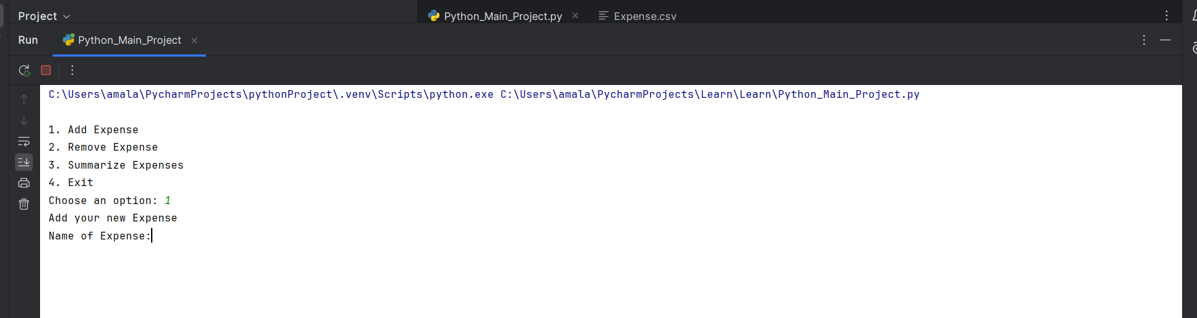

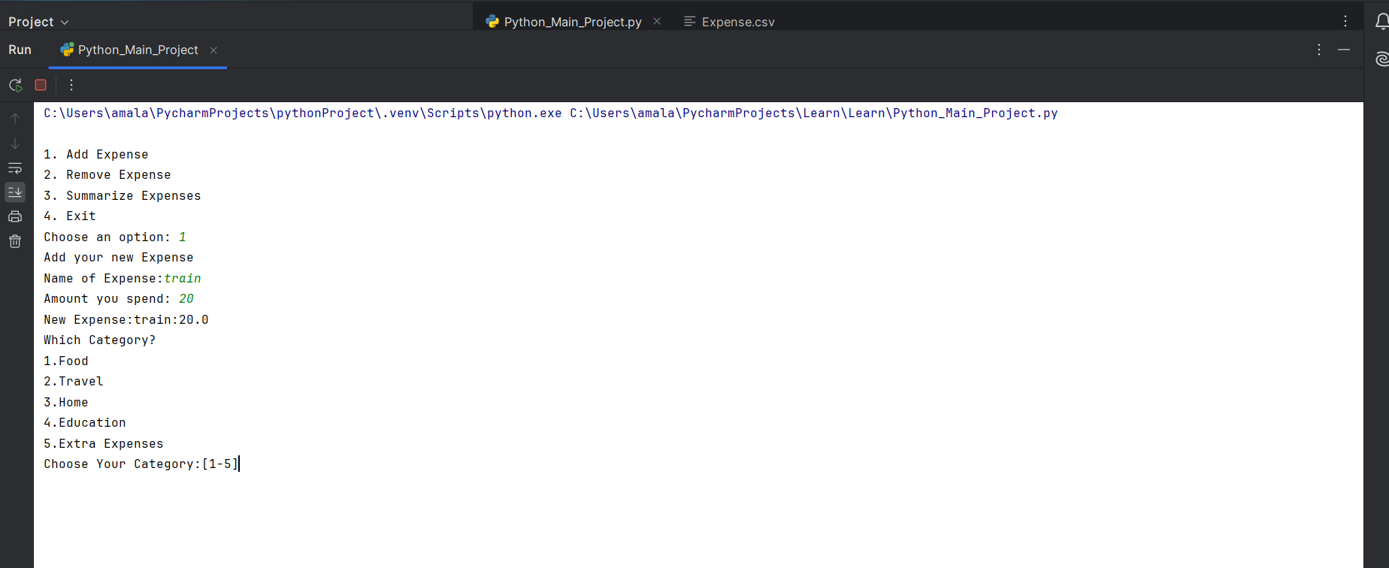

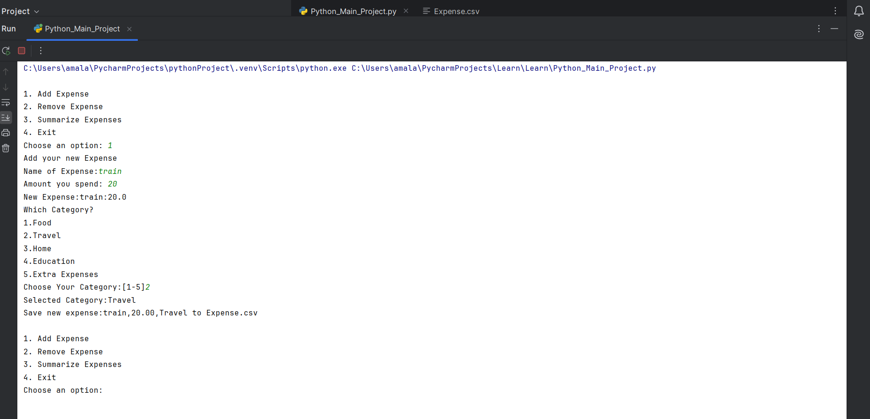

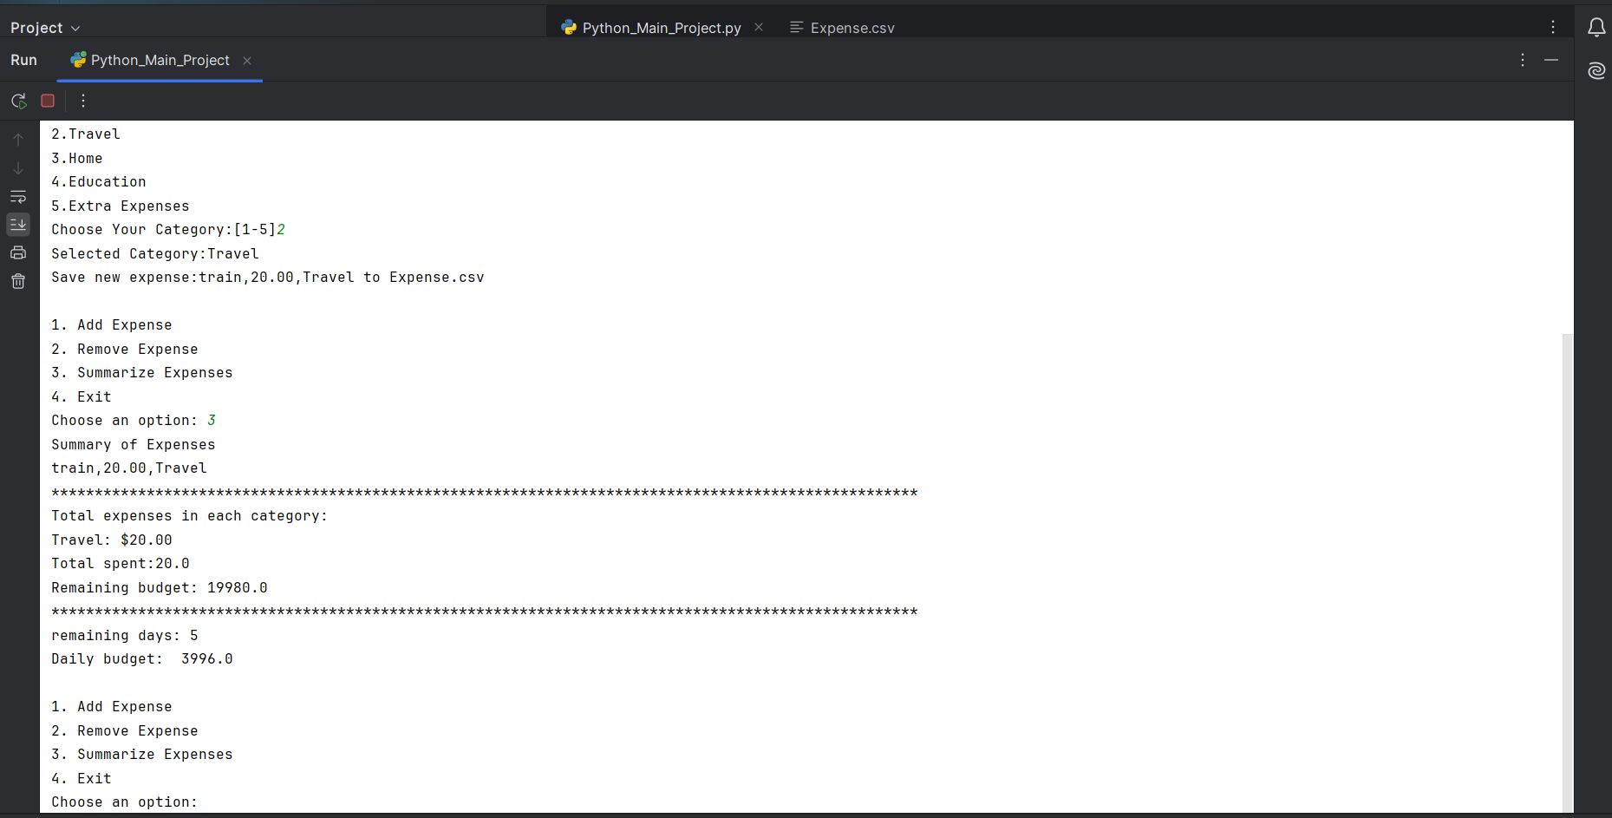

**Input**

import datetime  
import calendar  
class Expense:  
 def __init__(self,name,amount,category):  
 self.name=name  
 self.amount=amount  
 self.category=category  
 def __repr__(self):  
 return f"{self.name},{self.amount:.2f},{self.category}"  
def expense_details():  
 expense_file_path='Expense.csv'  
 budget=20000  
 while True:  
 print("\n1. Add Expense\n2. Remove Expense\n3. Summarize Expenses\n4. Exit")  
 choice = input("Choose an option: ")  
 if choice == '1':  
 add = add_expense()  
 save_file(add, expense_file_path)  
 elif choice == '2':  
 remove_expense(expense_file_path)  
 elif choice == '3':  
 summarize_expense(expense_file_path, budget)  
 elif choice == '4':  
 break  
 else:  
 print("Invalid choice. Please try again.")  
def add_expense():  
 print('Add your new Expense')  
 new_expense=input("Name of Expense:")  
 new_amount=float(input('Amount you spend: '))  
 print(f"New Expense:{new_expense}:{new_amount}")  
 expense_categories=['Food','Travel','Home','Education','Extra Expenses']  
 while True:  
 print('Which Category?')  
 for i,category_name in enumerate(expense_categories):  
 print(f"{i+1}.{category_name}")  
 value_range=f"[1-{len(expense_categories)}]"  
 selected_index=int(input(f"Choose Your Category:{value_range}"))-1  
 if selected_index in range(len(expense_categories)):  
 selected_category=expense_categories[selected_index]  
 print(f"Selected Category:{selected_category}")  
 expense=Expense(name=new_expense,amount=new_amount,category=selected_category)  
 return expense  
 else:  
 print('invalid syntax')  
 break  
def remove_expense(expense_file_path):  
 expense_name_to_remove = input("Enter the name of the expense to remove: ").strip()  
 updated_expenses = []  
 with open(expense_file_path, 'r') as f:  
 lines = f.readlines()  
 for line in lines:  
 line = line.strip()  
 if line:  
 parts = line.split(',')  
 if len(parts) == 3:  
 expense_name, expense_amount, expense_category = parts  
 if expense_name != expense_name_to_remove:  
 updated_expenses.append(line)  
 else:  
 print(f"Removing expense: {line}")  
 else:  
 print(f"Skipping improperly formatted line: {line}")  
  
 with open(expense_file_path, 'w') as f:  
 for expense in updated_expenses:  
 f.write(f"{expense}\n")  
 print(f"Expense {expense_name_to_remove} removed successfully.")  
def save_file(add:Expense,expense_file_path):  
 print(f"Save new expense:{add} to {expense_file_path}")  
 with open(expense_file_path,"a") as f:  
 f.write(f"{add.name},{add.amount:.2f},{add.category}\n")  
 pass  
def summarize_expense(expense_file_path,budget):  
 print(f"Summary of Expenses")  
 list=[]  
 with open(expense_file_path, 'r') as f:  
 lines = f.readlines()  
 for line in lines:  
 line = line.strip()  
 if line:  
 parts = line.split(',')  
 if len(parts) == 3:  
 expense_name, expense_amount, expense_category = parts  
 print(f"{expense_name},{expense_amount},{expense_category}")  
 list.append(Expense(name=expense_name,amount=float(expense_amount),category=expense_category))  
 else:  
 print(f"Skipping improperly formatted line: {line}")  
 amount_by_category = {}  
 for expense in list:  
 key = expense.category  
 if key in amount_by_category:  
 amount_by_category[key] += expense.amount  
 else:  
 amount_by_category[key] = expense.amount  
 print('*' * 100)  
 print("Total expenses in each category:")  
 for key, amount in amount_by_category.items():  
 print(f"{key}: ${amount:.2f}")  
 total_spent=sum([x.amount for x in list])  
 print(f"Total spent:{total_spent}")  
 remaining_budget=budget-total_spent  
 print(f"Remaining budget:",remaining_budget)  
 now=datetime.datetime.now()  
 days_in_month=calendar.monthrange(now.year,now.month)[1]  
 print('*'*100)  
 remaining_days=days_in_month-now.day  
 print(f"remaining days:",remaining_days)  
 daily_budget=remaining_budget/remaining_days  
 print(f"Daily budget: ",daily_budget)  
expense_details()